GAME DESIGN DOCUMENT
TileMania
A Challenging 2D Tile-Based Platformer

Game Title | TileMania
Version | 1.0.0
Date | March 2026
Author / Team | CS 4700 — Game Development, Cal Poly Pomona
Engine | Unity 6 LTS
Platform(s) | PC (Windows / macOS)
Genre | 2D Platformer / Action
Status | Active Development — Project 2 of 4

Version History
Date | Version | Changes Made
March 2026 | 1.0.0 | Initial GDD — all 8 sections drafted
March 2026 | 1.1.0 | Add level 2–3 encounter details
April 2026 | 1.2.0 | Finalize audio event list with FMOD paths
April 2026 | 2.0.0 | Post-alpha revision after playtesting

1. Project Info
💡 NOTE This section sets the foundation for the document. It tracks progress, versioning, and project intent.
⚠️ DESIGNER WARNING If you skip this section, your project will slowly splinter into different versions with no one sure which one is 'final.'

Game Title | TileMania
Author / Team | Keerthi Sreeram (Lead Designer)
Platform(s) | PC — Windows 10/11 & macOS 13+
Engine | Unity 6 LTS
Design Tools | Figma (UI mockups), GitHub (version control), FMOD Studio (audio)
Art Tools | https://assetstore.unity.com/packages/2d/characters/simple-2d-platformer-assets-pack-188518, Aseprite (pixel art), Blender (optional 3D refs), Meshy.ai (AI asset refs)
Audio Tools | Ableton, FMOD Studio 2.x, Audacity (SFX editing)
Monetization | None — academic project

2. Game Overview & Vision
💡 NOTE This is your north star. Anyone reading this section should understand what you're building, why it's unique, and who it's for.
⚠️ DESIGNER WARNING If you can't clearly say who this game is for and what makes it special, you're building something forgettable.

A. High Concept
Sky Travel is a crisp, pixel-art 2D platformer where a lone adventurer battles through tile-constructed worlds using precision jumping, designed to challenge reflexes while rewarding mastery.

B. Game Summary
The player navigates multi-zone levels built from auto-tiling tile maps. Each zone escalates in platforming complexity and enemy density. The core fantasy is 'tight control meets satisfying combat': The player is supposed to make sure to hold on to their coins and protect their health line and not bump into danger “thorns” or enemies which will make the player lose points. The final win can be accomplished By successfully reaching the checkpoint flag at the end of each level.

C. Player Journey Snapshot
First 10 Minutes
The player spawns at the start of Level 01 (Zone A — Intro). Simple, wide platforms ease them into running and jumping. A patrolling Slime enemy is positioned in an unavoidable path, forcing the player to shoot it or jump over it. A coin cluster rewards exploration. The level exit sits beyond a modest gap, achievable in under 3 minutes. The first potential death is falling from the platform which triggers a restart button that can teach the player what the implications of falling from the platforms are.

Mid/Late-Game Session
Vertical challenges get more tense and there are moving platforms as well as structurally placed platforms that make it harder to jump from one platform to another. This makes it harder for the player to move through the platforms but also more rewarding to get to the finish line.

D. Unique Selling Points (Game Pillars)
- Snappy Physics — Double jump feature makes it more fun to navigate the platforms and more useful in the later and harder levels
- Reactive Audio — Coin collection triggers an audio which can feel rewarding, and bumping into hazards triggers a swish sound which can warn the user without panicking them too much.
- Visual engagement – coins are animated making the game more engaging for the user. When bumping into a hazard, the player flashes red which also promotes simulation.

E. Target Audience
Primary: Ages above 12 who enjoy physics-based pressure with hard jumps and navigation. Player type: precision-driven, mastery-seekers who enjoy tight, repeatable loops. Secondary: Game development students learning 2D Unity architecture in an academic context.

F. Genre & Inspirations
Title | Inspiration Element
Moto X3M Bike Race Game | Jump difficulty, world changes based on levels
Temple Run | Appropriate visuals and matching music, adventure genre
Shovel Knight | Level zone theming, collectible placement rhythm

G. Tone, Look & Feel
Visual: Vibrant pixel art, 16×16 base tile grid, with a bright blue-sky aesthetic against earthy platforms and bright visuals for enemies and the main player.

Tone: Playful and adventurous

Audio: Classic playful background music taken from https://pixabay.com/music/search/background%20music/

For jumps, coin collects, hazards etc. https://assetstore.unity.com/packages/audio/sound-fx/true-8-bit-sound-effect-collection-lite-version-264063

3. Core Gameplay Design
💡 NOTE Describes how the game is played — primary loop, progression, and player feel.
⚠️ DESIGNER WARNING If your loop isn't simple and clear, your game will feel aimless and players will bounce before they understand the fun.

A. Core Gameplay Loop
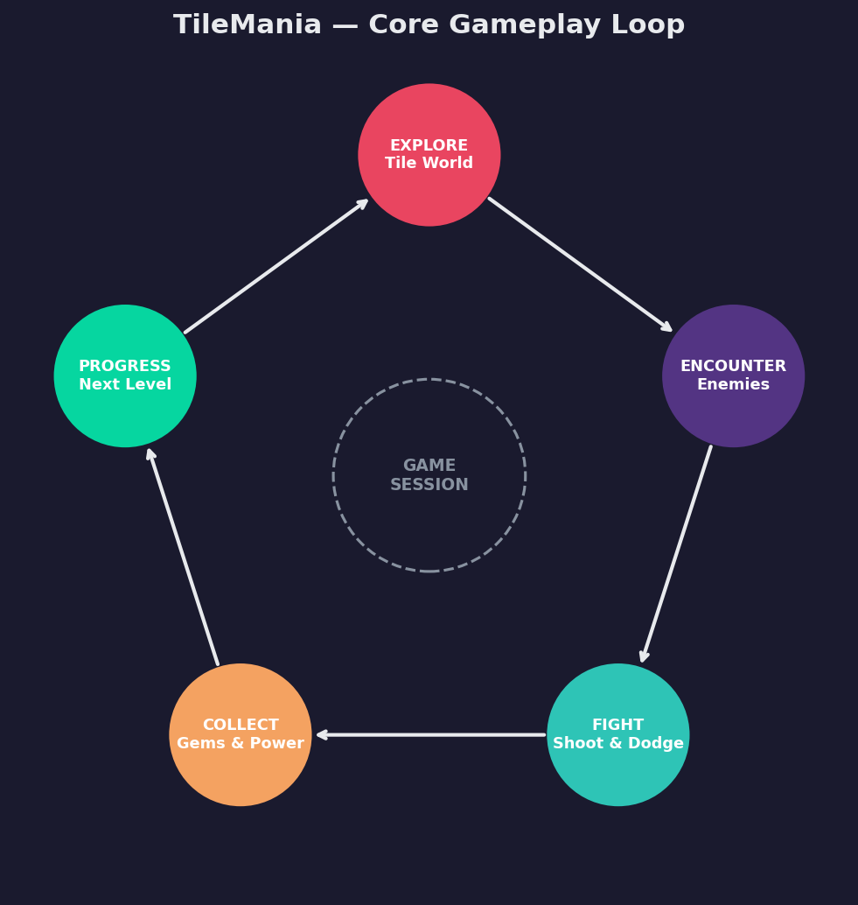
Fig 1. TileMania core gameplay loop — five repeating stages

Step | Action | Change | Reward
1 — Explore | Navigate tile platforms | New zones revealed | Sense of discovery
2 — Encounter | Enemies patrol paths | Threat introduced | Tension builds
3 — Fight | Push them off the platforms | Enemies eliminated | Screen clears, path opens
4 — Collect | Grab coins | Score increases, abilities unlocked | Satisfaction, momentum
5 — Progress | Reach level exit | New level loads | Mastery loop resets

B. Player Progression
- Levels 1: Introduce each mechanic individually (movement, shooting, hazards, enemies)
- Level 2: Combine mechanics, enemies placed near hazards, tight platform gaps near enemies

C. Controls & Input
Input | Action | Notes
← / → | Move left / right | Instant direction change (GetAxisRaw)
Space | Jump | Press twice to double jump

D. Difficulty & Challenge
- No difficulty selector in v1.0 — fixed progressive curve
- Unlimited retries from level start provides forgiving loop
- Health bar with 25% decrease in every encounter with hazard and enemy.
- v2.0 target: optional 'Relic mode' (one-hit kill, no checkpoints) for mastery players + shooting mechanism

E. Feedback Systems
Event | Visual Feedback | Audio Feedback | Physical Feedback
Player jumps | Sprite stretches up | True 8-bit sound effect collection jump sound
Player lands | Squash
Player hit | Flash with color of sprite turning red | True 8-bit sound effect collection slash sound |  | Camera shake (2.0, 0.3s)
Enemy dies | Squash + restart button
Coin collects | Collect animation | True 8-bit sound effect collection coin sfx
Player dies | Death animation | True 8-bit sound effect collection slash sound

4. Game Mechanics & Systems
💡 NOTE Breaks down the underlying rules and systems that support the gameplay loop.
⚠️ DESIGNER WARNING If this section is vague, your developers will invent mechanics on the fly and you'll spend months untangling them.

A. Core Mechanics

Movement System
Rigidbody2D-based movement with standard Unity gravity. Horizontal movement uses GetAxis with smooth acceleration and instant directional response. A single jump with one extra jump (double jump) is supported. Ground detection uses OverlapCircle at a ground check point against a configurable layer mask.

Shooting System
Combat is handled through collision-based damage, where contact with objects tagged "Damage" reduces the player's health by 25 and applies an upward knockback force equal to the jump force.

Player State Machine
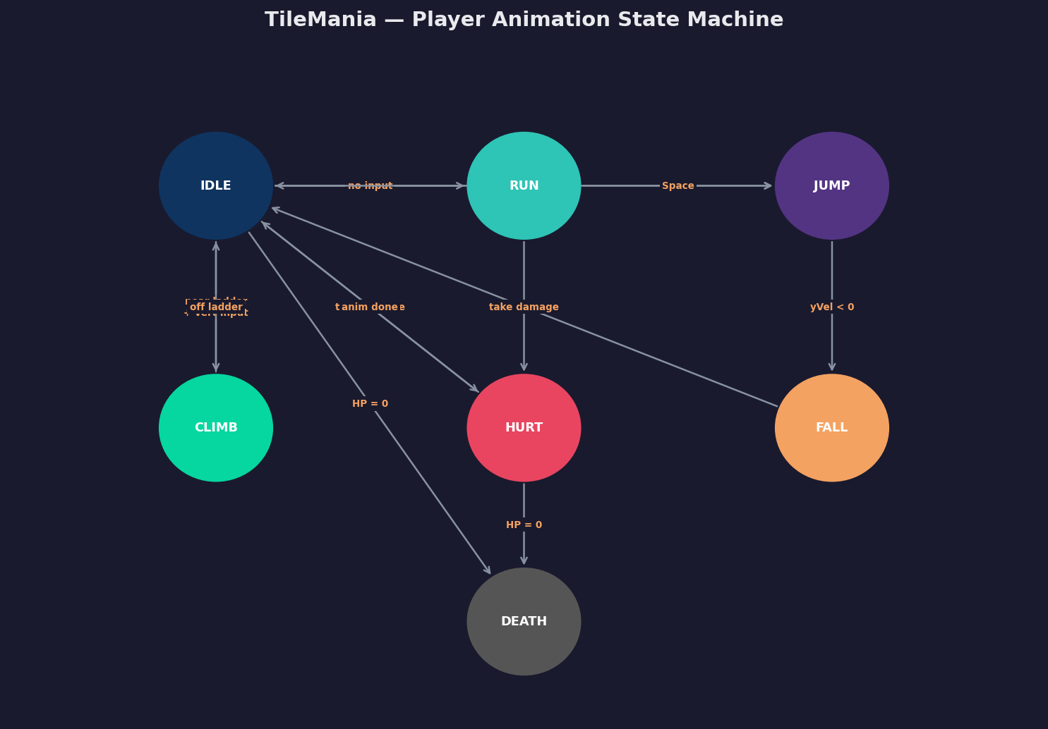
Fig 2. Player animation state machine — 7 states with transition conditions

B. Side Mechanics
- Moving Platforms: Lerp between 2+ waypoints; player parented on contact to inherit motion
- Checkpoint Flags: reaching checkpoint flags signify end of level and start of next level

C. Interaction Mechanics
All interactions use Unity Collider2D triggers. There is no 'use key', proximity or overlap is sufficient. Level exits: trigger overlap + short delay. Collectibles: trigger overlap + immediate destroy. No dialogue trees or inventory in v1.0.

D. Economy & Resources
Resource | How Earned | How Spent | Notes
Coins (Gold) | Scattered in levels | Score multiplier only — cosmetic | No shop in v1.0
Lives | Start with 4 | Lost on bumping into hazards | Lives reset when restarted
Score | Coins + enemy kills | Level advancement

5. Narrative, World & Characters
💡 NOTE Even a light-story game needs defined tone, world logic, and character identity.
⚠️ DESIGNER WARNING If you leave this empty, your story will creep into the game in a poorly integrated, confusing way.

A. Themes & Emotional Arc
SkyTravel is a lighthearted 2D platform where the challenge slowly builds as you move through each level. You start on simple platforms and by the time things get harder, the movement already feels natural. Dying just means trying again, and the game never takes itself too seriously.

B. Story Overview
A young adventurer explores a series of ancient sky platforms their ancestors once built, now overrun with creatures and obstacles. The goal is simple, get through each level, deal with whatever is in the way, and see what is waiting at the end.

C. Worldbuilding
SkyTravel takes place across floating ruins and sky platforms that stretch higher with each level. The world tells its story through what you see, crumbling and moving structures, wandering creatures, and platforms that feel more unstable the further up you go. No dialogue just vibes and whatever is trying to knock you off the edge.

D. Main Characters
Character | Role | Description
The Archer | Player character | Silent protagonist. Lithe, fast. Pixel art: white and petite
Emerald Enemy | Tier 1 enemy | Bouncy ground patrol. Green pixel blob.

E. Player Agency
v1.0: Linear path with minor route choices (top road vs. bottom road on split platforms). Story is fixed, no branching. v2.0 goal: unlock alternate zone ordering after first completion; cosmetic unlocks from high-score grades.

6. Level & Encounter Design
💡 NOTE Outlines the structure and goals of the spaces the player moves through.
⚠️ DESIGNER WARNING If you can't explain what a typical level feels like or what the player is trying to accomplish, your content will lack purpose.

A. Objectives
- Primary: Reach the level exit alive
- Secondary: Collect all coins
- Optional: Defeat all enemies in zone

B. Structure & Layout — Level 01 Overview
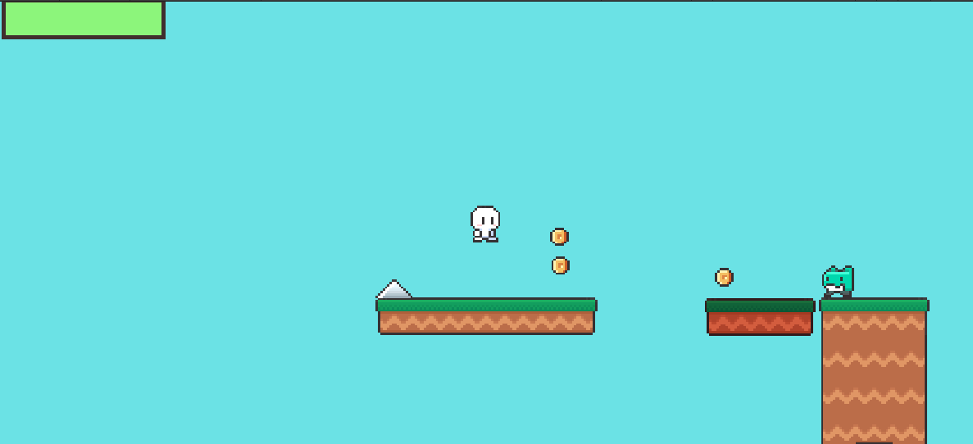
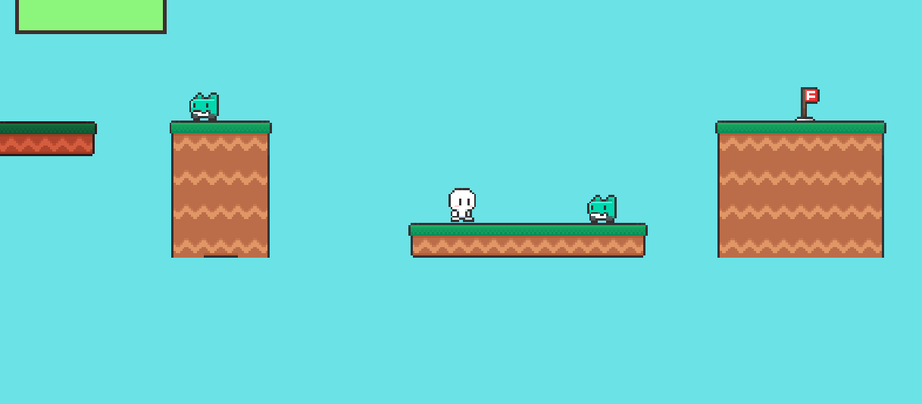

Fig 3. TileMania Level 01 — four-zone horizontal layout with platform, hazard and enemy placement

C. Gameplay Flow (Level 01 Beat Sheet)
- Beat 1 (0–30s): Spawn, see wide platform → run right, jump gap → first coin cluster
- Beat 2 (30–60s): Encounter Slime on narrow bridge → shoot or jump over → hazard spikes below
- Beat 5 (160–180s): Final gap sprint → level exit glow → next level transition

D. Interactive Elements
- Trigger zones: level exit, checkpoint flags
- Moving platforms: horizontal

E. Progression Gates
- Level 01→02: Completing level (reaching exit)

F. Environmental Storytelling
The world of SkyTravel tells its story through the platforms and backgrounds around you. Each level has little details that hint at what happened there before you showed up, like worn out structures, strange enemy patterns, and backgrounds that shift the higher you climb.

7. UI, UX & Accessibility
💡 NOTE Covers how players interact with the game outside direct mechanics.
⚠️ DESIGNER WARNING If this section is blank, your player will suffer even if the mechanics are great. Clarity always beats cleverness.

HUD Layout


Fig 4. TileMania HUD wireframe — 1920×1080 layout with all persistent UI elements

B. Core UI Elements
Element | Position | Description
Health | Top-Left | Player loses 25% of health for every encounter with enemy

Menus & Screens





D. UX Flow
📍 FLOW Main Menu → [Start] → Level Load → Gameplay → [Exit trigger] → Level Complete Screen → Next Level OR [Game Over] → Game Over Screen → [Try Again] → Level Reload

E. Onboarding
- Level 01 Zone A uses implicit teaching: wide gaps before introducing narrow ones; single enemy before groups
- First 30 seconds: no text prompts, player discovers jump by approaching a gap
- First enemy encounter: enemy is isolated with coin reward behind it, encourages engagement

F. Accessibility Options
Feature | v1.0 | v2.0 Target
Key Remapping | No | Yes — full via Settings
Colorblind Mode | No | Hazard outline mode (spike glow)
Screen Shake Toggle | No | Yes — slider 0–100%
Screen Flash Toggle | No | Yes — disables invincibility flash
Subtitles | N/A — no dialogue | N/A
Windowed / Fullscreen | Yes | Yes
Resolution Selector | Yes | Yes + UI scale slider

8. Audio Design — FMOD Integration
💡 NOTE This section expands on the Production Notes' audio system design with full FMOD architecture, parameter maps, and C# integration patterns.
⚠️ DESIGNER WARNING Audio designed late becomes an afterthought, it needs to be architected early to support dynamic music and reactive SFX properly.

A. FMOD Event Hierarchy
https://assetstore.unity.com/packages/audio/sound-fx/true-8-bit-sound-effect-collection-lite-version-264063 The True 8-bit sound effect collection was used for the SFX of coin, hazard, jump etc.

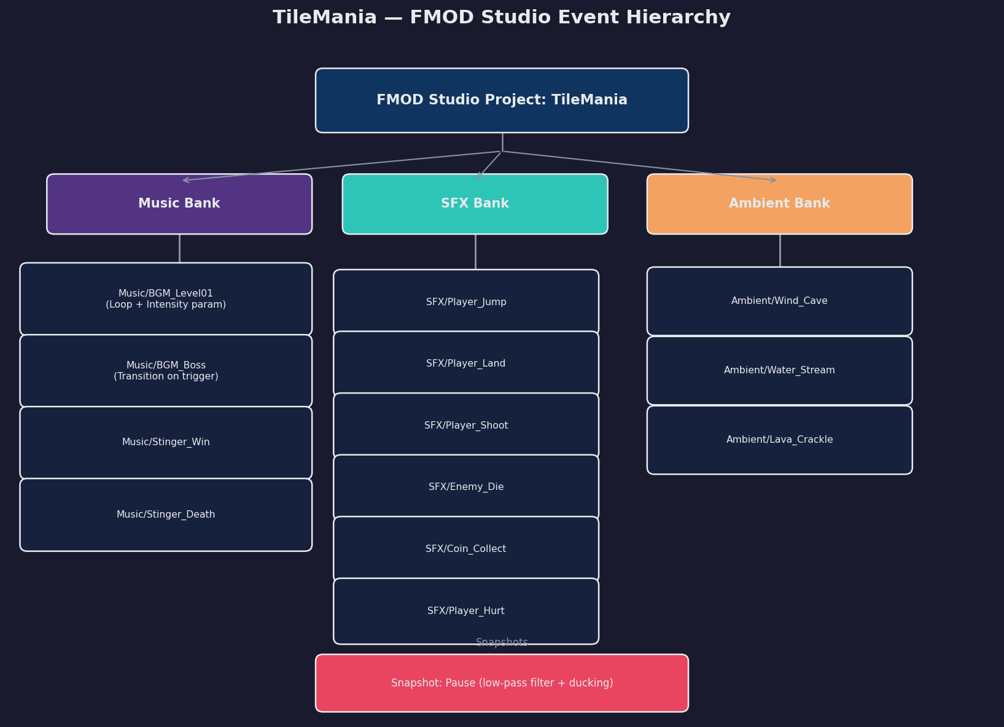
Fig 5. TileMania FMOD Studio event tree — Music Bank, SFX Bank, and Ambient Bank with all events

Fig 6. FMOD Intensity parameter timeline (top) and multi-layer stem architecture (bottom)

C. C# Integration — Code Snippets
The AudioManager singleton wraps all FMOD calls. It persists across scenes via DontDestroyOnLoad and exposes a clean API to all other systems.
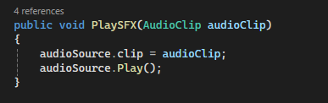
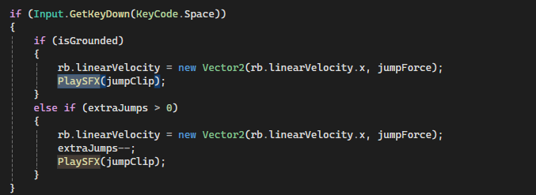
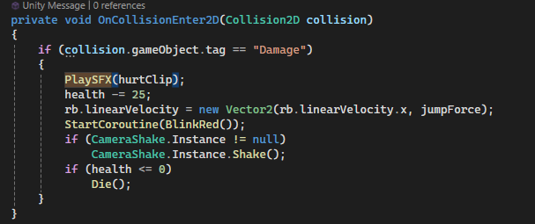
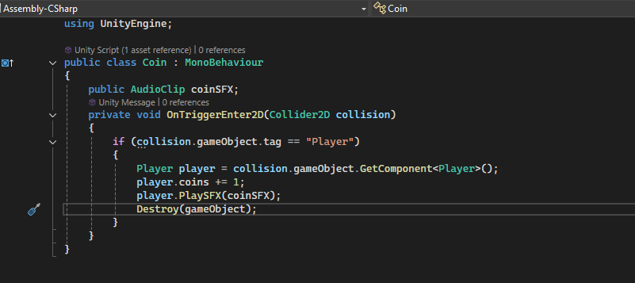
Fig 7. TileMania AudioManager.cs — FMOD C# integration patterns for one-shots, parameters, and snapshots

D. Full Audio Event List
Event Path | Trigger | Type
Music/BGM_Level01 | Scene load | Loop + parameter
SFX/Player_Jump | Jump input | One-shot
SFX/Player_Coin Collect | If collision with coins | One-shot
SFX/Player_Hurt | TakeDamage() called | One-shot

E. Audio Bus Architecture
Bus | Children | Volume | Notes
Master | Music, SFX, Ambient | 100% | Global volume control
Music | BGM events, Stingers | 80% | Ducked by Pause snapshot
SFX | Player, Enemy, UI, Ambient SFX | 90% | Not ducked on pause
Ambient | Ambient bed loops | 60% | Ducked on boss fight (Intensity ≥ 3)
UI | Menu clicks, Score popups | 85% | Bypasses all snapshots

9. Production Notes
💡 NOTE Planning material, milestones, team roles, and risk assessment.
⚠️ DESIGNER WARNING If you ignore this section, future-you will wonder why everything is late, broken, and missing half the features.

A. Team Roles
Role | Name / Assigned To | Responsibilities
Lead Designer | Keerthi Sreeram | GDD ownership, level design, design reviews

B. Milestones
Phase | Target | Deliverables
Prototype | Week 3 | Player movement, 1 enemy type, basic tilemap, no audio
Vertical Slice | Week 6 | Level 01 complete, all core systems, placeholder art
Alpha | Week 10 | Levels 1–5, all enemy types, FMOD integrated, HUD functional
Beta | Week 13 | All 10 levels, full audio, bug pass, playtesting complete
Gold / Submission | Week 16 | Polished build, GDD updated, postmortem written

C. Out-of-Scope Features (v1.0)
- Multiplayer / co-op mode
- Enemy AI pathfinding (A* or NavMesh), patrol-only in v1.0
- Procedural level generation
- In-game currency shop
- Achievement system
- Mobile / controller support

D. Marketing Hooks
- Trailer moment: Player arrow kills three enemies in a chain while falling, all with audio stem intensifying
- Pitch phrase: 'The tight jump you've been chasing. The world you didn't expect.'
- Wishlist bait: Animated GIF of the FMOD music intensity shifting live during gameplay

E. Risks & Unknowns
Risk | Likelihood | Impact | Mitigation
FMOD integration complexity | Medium | High | Prototype audio separately in Week 2; use FMOD Unity package
Jump feel tuning time | Medium | High | Prototype fall/jump multipliers in Week 1; lock values early
Asset pipeline (sprites) | Medium | Medium | Use free Pixel Adventure pack as fallback; allocate art buffer week

F. Live Ops & Post-Launch
- v1.1 patch: Bug fixes from student playtesting feedback
- v1.2: Colorblind mode + screen shake toggle (accessibility backlog)
- v2.0: 3 additional levels + boss enemy phase 4 + save/load system
- Community: itch.io page with changelog; open GitHub repo for course reference

— END OF DOCUMENT —
TileMania GDD v1.0 | CS 4700: Game Development| Cal Poly Pomona | March 2026

